**MP3: Tomb Raider Robot**

*Bryant Zhao, Andrew Zhang, Aniket Shirke, Eric Zheng*

**Design Paradigm**

In this MP, we restructured our code for MP2 and made a new architecture to ensure thread-safety and functionality. We reduced the clock period from MP2 to ensure **safety-critical** requirements, divided each modular task into separate threads, rewrote the entire navigation handler as our **performance-critical** module, and fixed object-identification to meet the **mission-critical** requirements. With each of the 3 primary requirements each being refactored into independent threads, we can now easily maintain well-formed dependencies. We used rate-monotonic scheduling policy to determine thread priorities based on the lengths of their periods. The priority ordering of threads is as follows (with higher value denote higher thread priority):

1. Safety thread – Priority 5 - **safety-critical module**
2. Navigation thread – Priority 3 - **mission-critical module**
3. Object Detection thread – Priority 1 - **performance-critical module**

The contour mapping module is embedded in the main thread. With a global queue collecting all motion state changes, the contour-mapper records all necessary waypoints during the mission and draws the map at the end of our main thread. Detailed designs will be discussed in sections below.

**Dependency Graph**

// this needs to be re-drawn

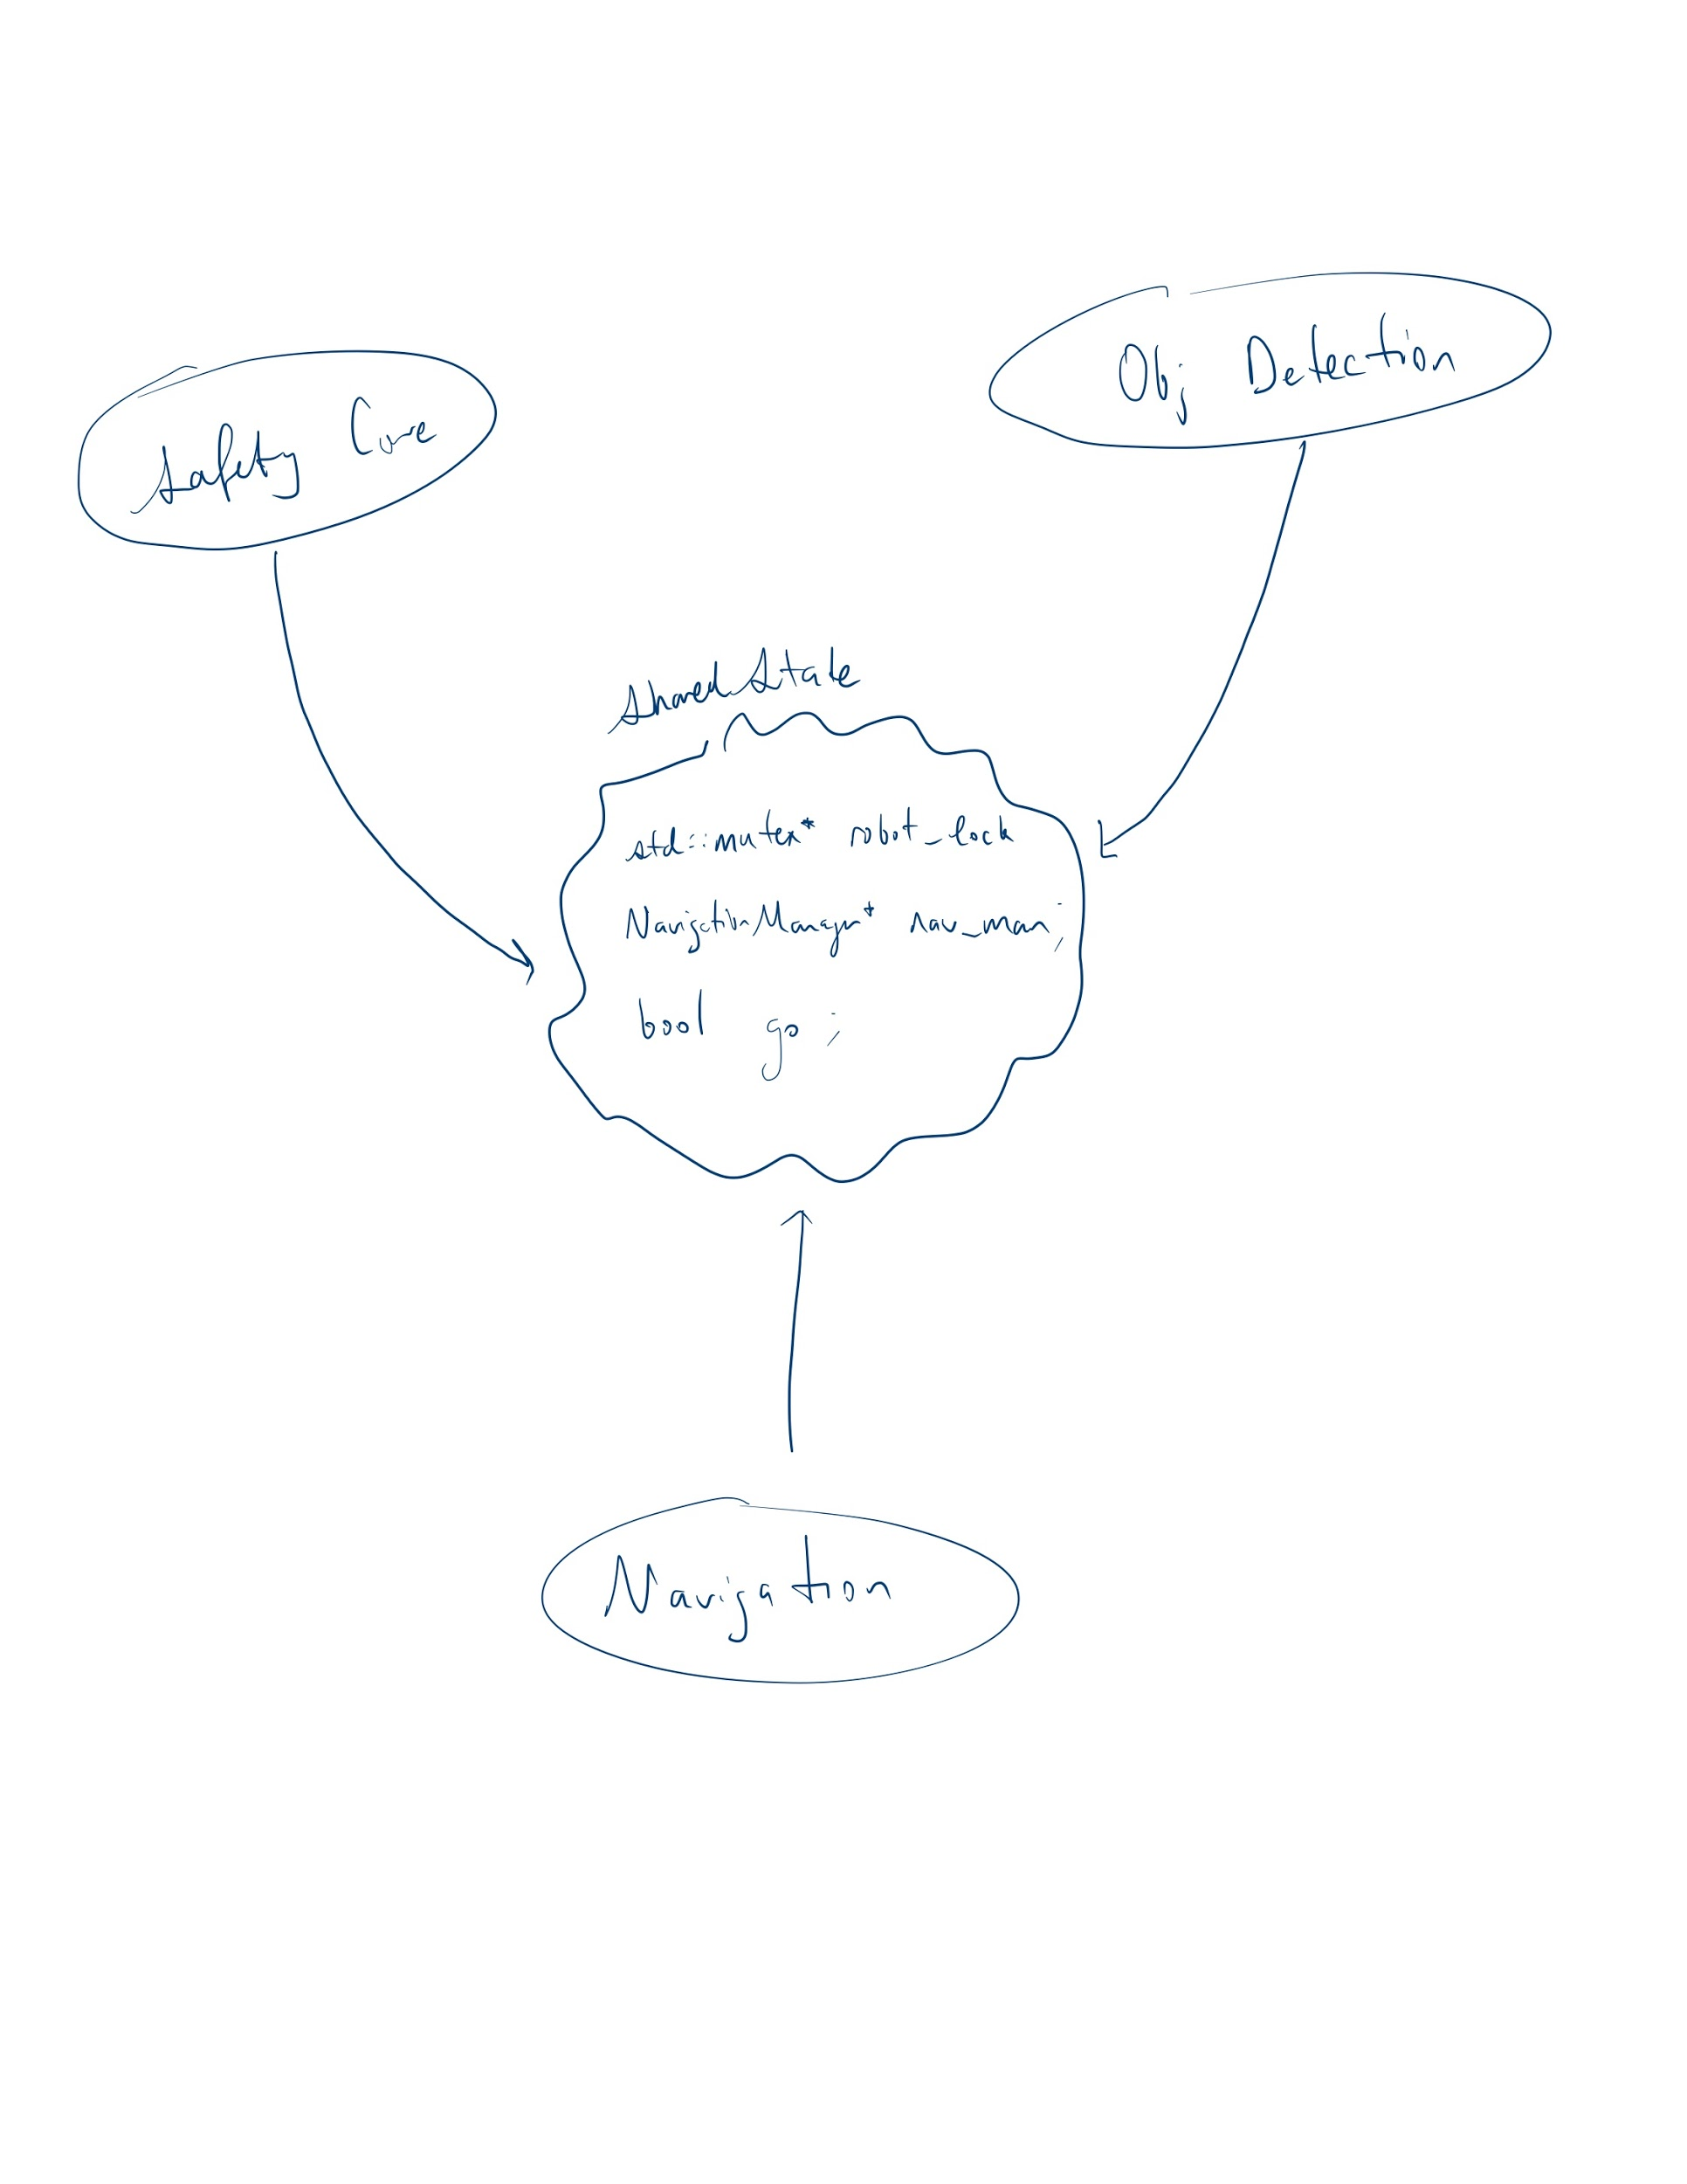

**Safety-critical Module**

1. Avoid hard wall collision
2. Avoid falling off cliffs
3. Meeting the 120s timing constraint
4. Safe mission abort

**Mission-critical Module**

1. Navigation Algorithm
2. Accurate contour-mapping
3. Self-adaptive route planning

**Performance-critical Module**

**Issues Encountered**

gggggggg